

**课程小作业报告**

**计算机基本原理**

|  |  |
| --- | --- |
| **课程名称：** | **计算机与软件工程概论** |
| **学生姓名：** | **快要变成猪了QwQ** |
| **学生学号：** | **XXX** |
| **学生专业：** | **软件工程** |
| **开课学期：** | **2023-2024学年第1学期** |

**软件学院**

**2023年10月**

**课程作业1：计算机与计算思维**

## 问题1：计算机基本原理

以Pep/8虚拟计算机为基础：

1： 学习数据表示、二进制运算、布尔逻辑运算、门电路与加法器、CPU结构及冯.诺依曼型计算机体系结构及原理（程序存储及取指令-执行指令）、CPU指令、编程语言（Pep/8机器语言及其汇编语言）；

2：利用Pep/8计算机，求解如下问题; (注意，这里问题描述采用类c++语言)

int a, b, c; // 三个整型变量

a = 1;

b = 2;

c = a + b; // 加法，并输出c

### 知识与技术总结

报告要求，就解决问题过程中，学习到的知识与技术，按章节总结阐述，突出重点；

#### 数据表示

First of all, A basic problem at all levels of abstraction is the mismatch between the form of the information to be processed and the language to represent it. A program in machine language

processes bits. A program in a high-order language processes items such as arrays. So **matching the information to the language** is a basic problem at all levels of abstraction in the modeling process of problem solving.

**Binary** is a base-2 number system that uses only two digits, 0 and 1, to represent all numbers.

In binary, each digit’s place value is twice as much as that of the next digit to the right. **Signed integers** use two’s complement binary representation in which the first bit is the sign bit and the remaining bits determine the magnitude. For positive numbers, the two’s complement representation is identical to the unsigned representation. For negative numbers, however, the two’s complement of a number is obtained by taking 1 plus the ones’ complement of the corresponding positive number.

Similarly, **hexadecimal** (hereinafter referred to as “hex”) is a base-16number system whose digits are 0, 1, 2, 3, 4, 5, 6, 7, 8, 9, A, B, C, D, E and F. One hex digit corresponds to four binary digits and vice versa, e.g., (6 A)H=(0110 1010)B. Also hex numbers are often used for abbreviated ASCII and abbreviated memory address.

A **floating point number** is stored in a cell with three fields—a one-bit sign field, a field for the

exponent, and a field for the significand. Except for special values, numbers are stored in binary

scientific notation with a hidden bit to the left of the binary point that is assumed to be 1. The

exponent is stored in an excess representation. Four special values are zero, infinity, NaN, and

denormalized numbers. The IEEE 754 standard defines the number of bits in the exponent and

significand fields to be 8 and 23 for **single precision**, and 11 and 52 for **double precision**.

* + 1. **二进制运算**

In the field of Digital Electronics, binary subtraction is usually performed using 2’s complement.

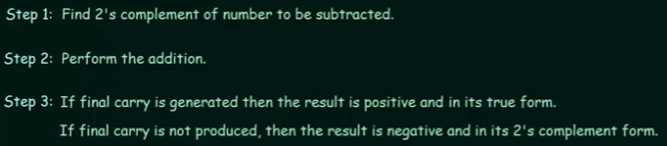Steps are as followed:

Specially, **ASL**, which stands for arithmetic shift left, multiplies a binary value by 2, and **ASR**, which stands for arithmetic shift right, divides a binary value by 2.

* + 1. **布尔逻辑运算和门电路与加法器**

**Boolean logical operators** on binary integers include AND, OR, XOR, NAND, NOR and NOT, all

of which have corresponding **truth tables** and notations referred to as **Gates**. We can perform single bit addition using **a Half Adder** which is composed of a AND gate and a XOR gate

like this: 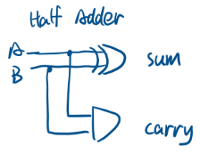 However, a Half Adder does not take the carry bit produced by the preceding addition into its account, so

we design **a Full Adder** to handle this issue: 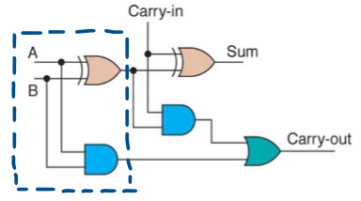 And finally, we connect several Full Adders together to build **a Ripple Carry Adder**:

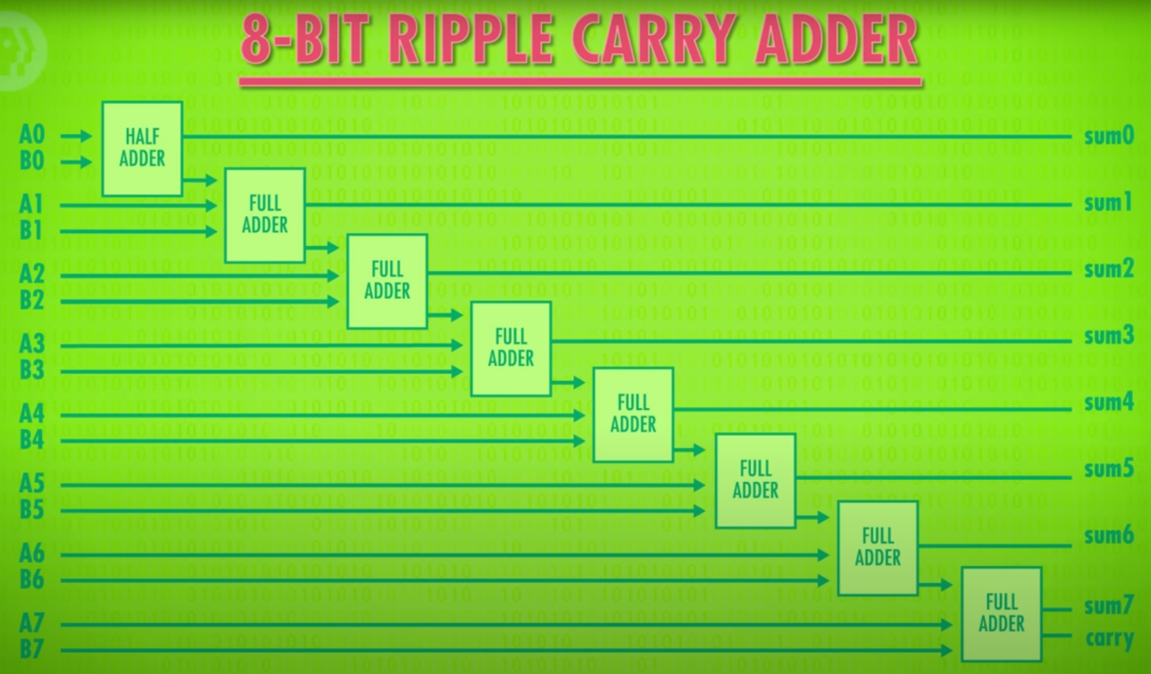

* + 1. **CPU结构及冯诺依曼型计算机体系结构及原理、CPU指令**

Virtually all commercial computers are based on the **von Neumann design principle**, in which main memory stores both data and instructions. The three components of a von Neumann machine are the **central processing unit** (CPU), **main memory** with **memory-mapped I/O devices**, and **disk**. The CPU contains a set of registers, one of which is the program counter (PC), which stores the address of the instruction to be executed next.

The CPU has an instruction set wired into it. **An instruction** consists of an instruction specifier and an operand specifier. The **instruction specifier**, in turn, consists of an opcode and possibly a register field and an addressing mode field. The **opcode** determines which instruction in the instruction set is to be executed. The **register field** determines which register participates in the operation. The **addressing mode field** determines which addressing mode is used for the source or destination of the data.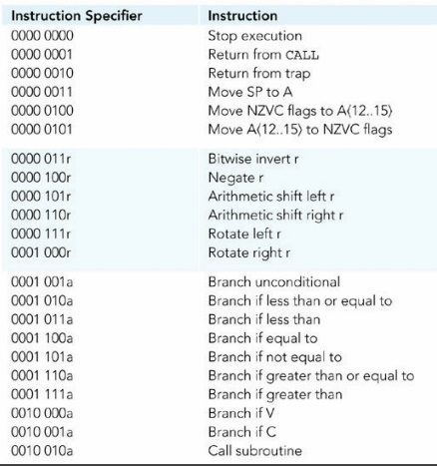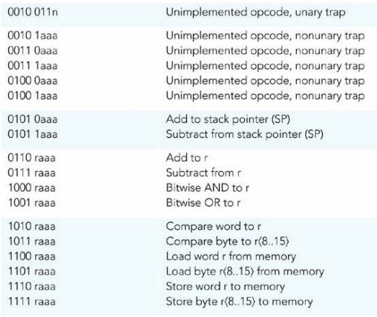

Each addressing mode corresponds to a relationship between the operand specifier (OprndSpec) and the operand (Oprnd). In the direct addressing mode, the operand specifier is the address in main memory of the operand. In mathematical notation, Oprnd = Mem[OprndSpec].

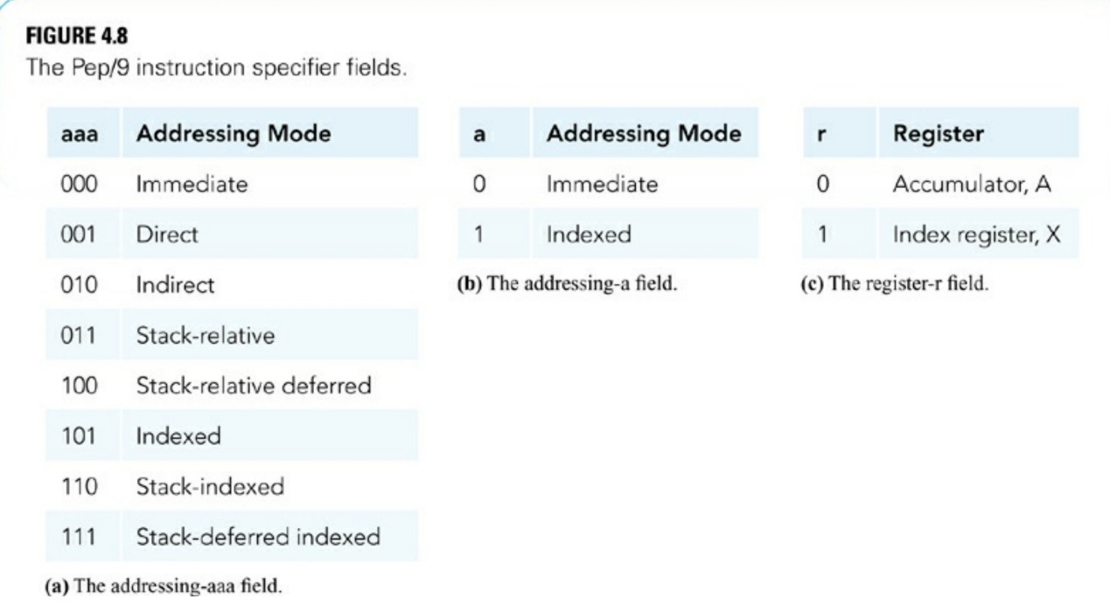

To execute a program, a group of instructions and data are loaded into main memory, and then the von Neumann execution cycle begins. The von Neumann execution cycle consists of the following steps: **(1) fetch the instruction specified by PC, (2) decode the instruction specifier, (3) increment PC, (4) execute the instruction fetched, and (5) repeat by going to Step 1.**

### 问题求解

The two numbers to be added are 5 and 3. The program stores them at Mem[000D] and Mem[000F]. The first instruction loads the 5 into the accumulator, and then the second instruction adds the 3. At this point the sum is in the accumulator.

### Pep/8程序

0000 C1000D ;A <- first number

0003 61000F ;Add the two numbers

0006 910011 ;Convert sum to character

0009 F1FC16 ;Output the character

000C 00 ;Stop

000D 0005 ;Decimal 5

000F 0003 ;Decimal 3

0011 0030 ;Mask for ASCII char

### 总结

* + 1. **遇到的问题与解决方案**

We want to output this result, but the only output instruction for this Level ISA3 machine

is to store a byte in ASCII format to the output device at Mem[FC16]. The problem is that our result is 0000 1000 (bin). If the store byte instruction tries to output that, it will be interpreted as the backspace character.

So, the program must convert the decimal number 8, 0000 1000 (bin), to the ASCII character 8, 0011 1000 (bin). The ASCII bits differ from the unsigned binary bits by the two extra 1’s in the third and fourth bits. To do the conversion, the program inserts those two extra 1’s into the result by ORing the accumulator with the mask 0000 0000 0011 0000.

The accumulator now contains the correct sum in ASCII form. The store byte instruction sends it to the output device.

### 参考

[1] Computer Systems, Fifth Edition. https://computersystemsbook.com/

（下载Pep/8虚拟机）

[2] J. 斯坦利·沃法德 - 计算机系统：核心概念及软硬件实现（原书第4版） (2015, 机械工业出版社)

（阅读相关章节）

[3] J. Stanley Warford - Computer Systems (2016, Jones _ Bartlett Learning)

[4] Neso Academy - [Binary Subtraction using 2's Complement](https://www.youtube.com/watch?v=L_m7jBvtzpQ)

[5] CrashCourse - [How Computers Calculate - the ALU: Crash Course Computer Science #5](https://www.youtube.com/watch?v=1I5ZMmrOfnA&list=PL8dPuuaLjXtNlUrzyH5r6jN9ulIgZBpdo&index=6)